**Grouped by type**

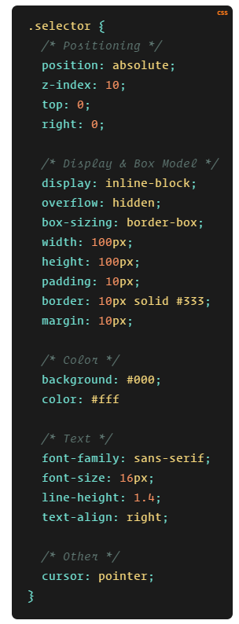

CSS tips trick:

<https://css-tricks.com/poll-results-how-do-you-order-your-css-properties/>

Convention **BEM**:

<http://getbem.com/>

CSS Tutorial:

[https://www.youtube.com/watch?v=iNKwWRHCeWE](https://www.youtube.com/watch?v=iNKwWRHCeWE%20)

Cánh tính độ cụ thể của CSS Selector: <https://www.youtube.com/watch?v=I4BPQsERc0w&t=0s>